Working with Hermary Amadeus Cameras
Hermary’s software is divided into Amadeus Tools and the Composer.

Amadeus Tools
Amadeus Tools allows you to connect and update devices, change various
hardware/software settings (such as IP addresses), and access the Raw Image Viewer and XY Viewer.
When opening the software for the first time, any connected devices should be found automatically and auto-assigned IP addresses, appearing in the “Devices” menu on the left side of the screen. The MVS208 is a control module/switch and the TDS2000 is a 3D
camera.
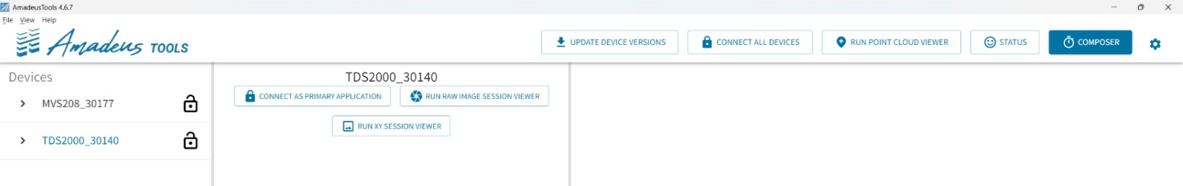
You can check the connection status of your devices under the “Status” section by clicking the button on the right side of the screen.
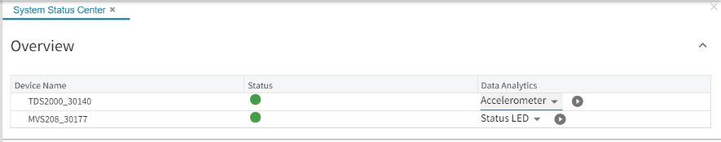
The “Data Analytics” tab can be used to access various charts by selecting the metric of interest from the drop-down menu and clicking on the play button.

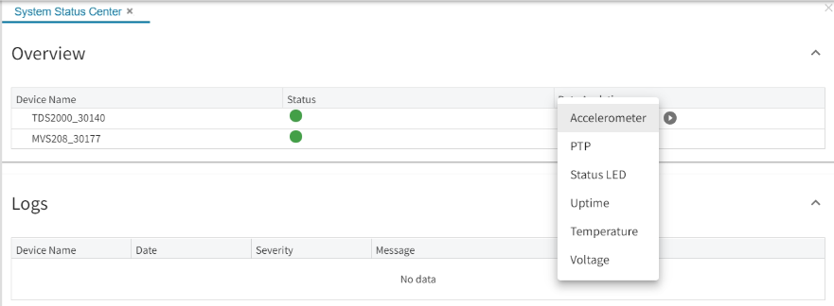
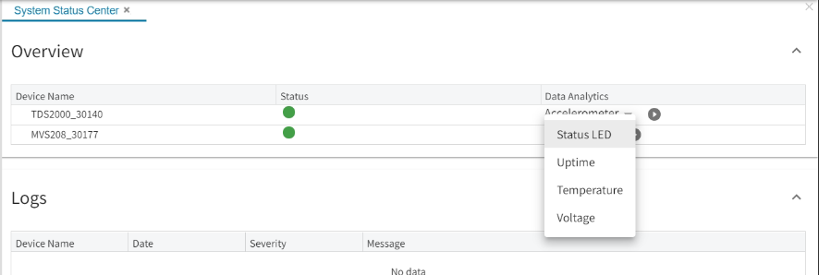

Setting IPs Manually
If you’d like to change the static IP of a device, click on the lock icon next to the device you’d like to modify to connect to the device (the lock should turn green). Navigate under Transport Layer Control>GigEVision and change the Persistent IP Address, Subnet Mask and Default Gateway as required.

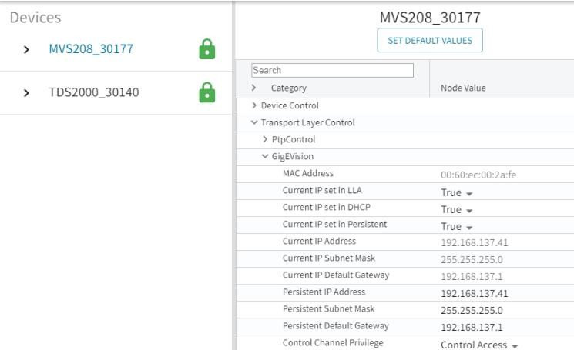

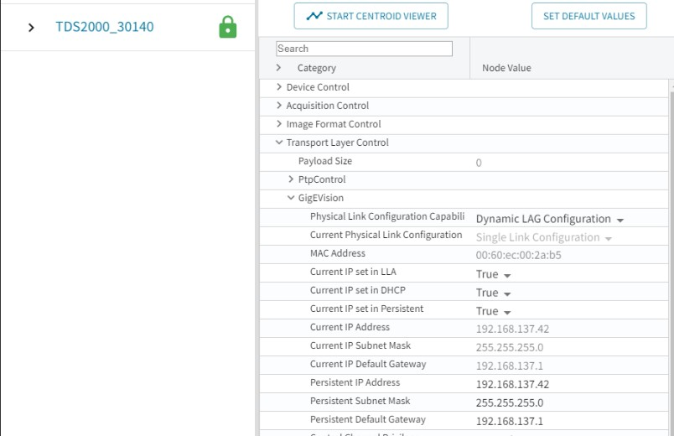

Raw Image Viewer
After connecting to a TDS2000 device, select the “Start Raw Image Viewer” button to view the Raw Image Viewer. This will open a live feed of the camera. The camera’s intensity can be modified using the sliders on the bottom dashboard and the row/column position of your cursor is shown to the right of the intensity slider.

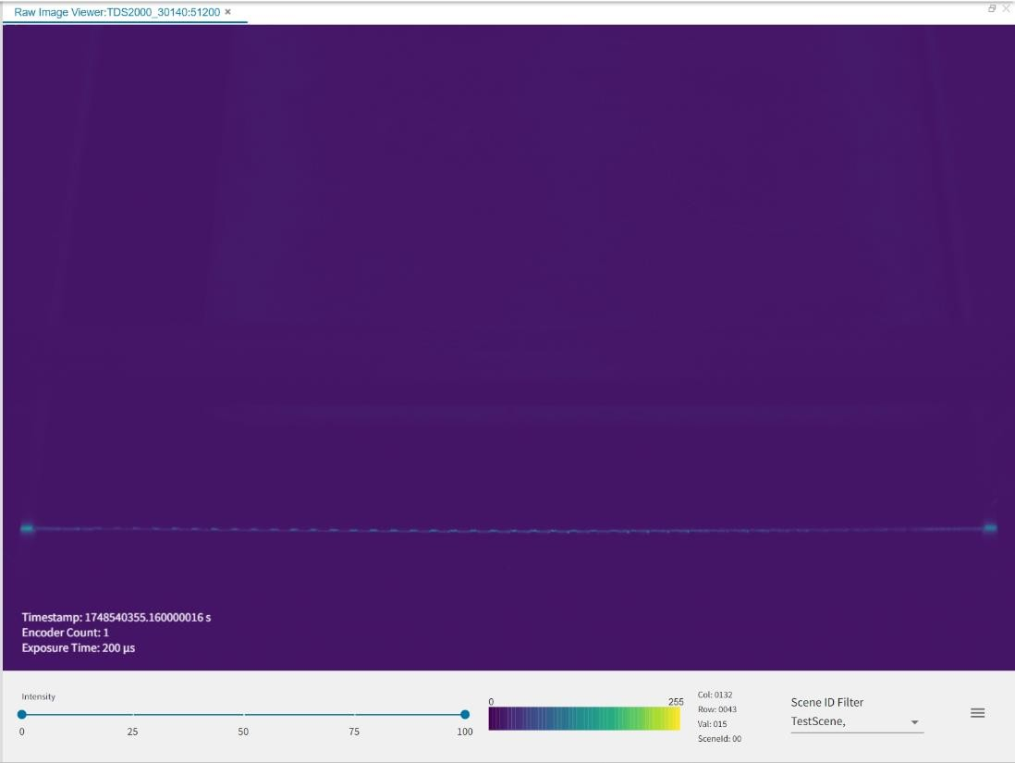
Additional settings and intensity graphs for individual rows or columns can be accessed by clicking the 3 lines on the far-right side of the dashboard. The slider button on the bottom of the window is used to cycle between row and column followed by the specific row or column you’d like to view.

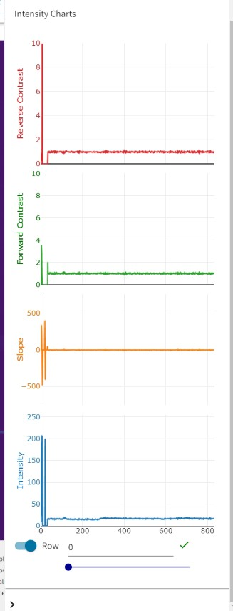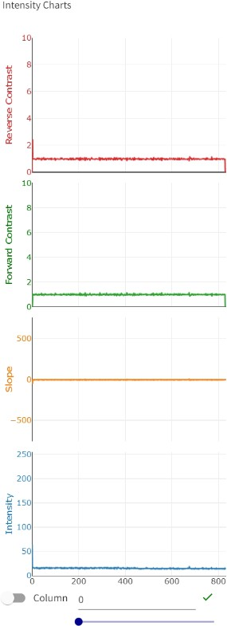

XY Viewer
To open the XY Viewer, select the “Start XY Viewer” button from the TDS2000 menu.
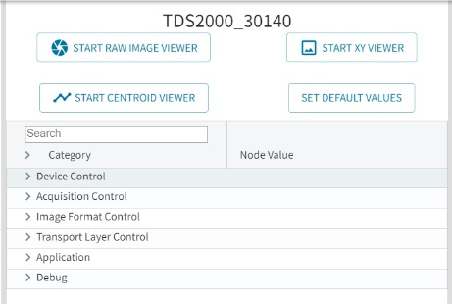

The XY Viewer can be used to verify that the 3D camera has been mechanically calibrated correctly, as the line should be as close to vertical as possible after calibration.
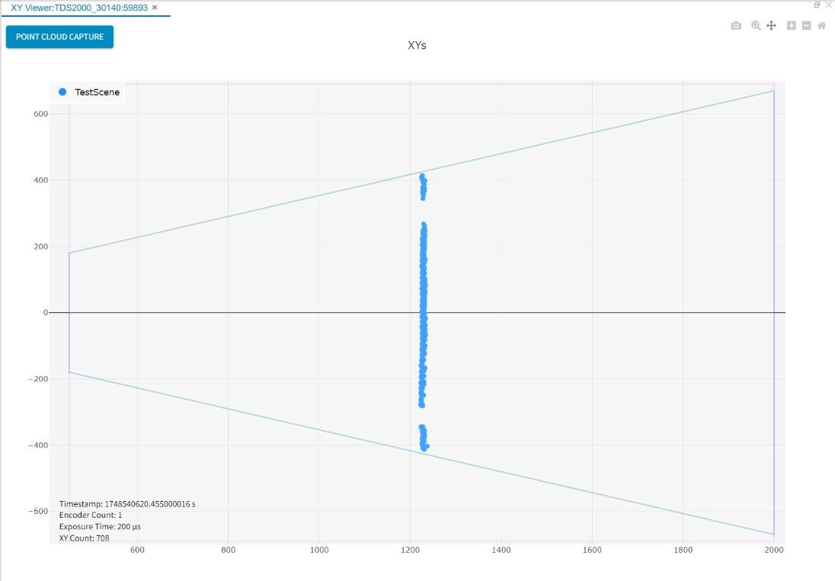

The Composer
The Composer is a software application that is used to configure the devices connected to the Amadeus architecture. The Composer’s responsibility is to generate the command execution files used by the devices within a system to perform the tasks desired for a given application. Like the composer of a piece of sheet music, the Composer is in charge of orchestrating the actions of each individual device and its component modules at a
specific moment in time. The generalized syntax generated by the Composer, gives the user an unprecedented level of flexibility and customization possibilities when configuring the operation of a system. The Composer is the primary method of controlling timing in the Amadeus platform.
An example of the timing diagram of a sheet of light setup in the Composer is shown above. The timing diagram frame is made up of the following elements:
- On the left side is the device name, TDS2000_30020.
- Below the device name, the device has reported itself as having both a laser and imager module.

- To the right of this information, there is the main timeline.
- Along the top is a scale, which starts at 0 µs and runs for 20,000 µs.
- On the timeline beside the LASER0 module there is a laser command powered from 0 µs - 500 µs.
- The laser command will turn on the laser for 500 µs.
- On the timeline beside the IMAGER0 module there is an imager command integrating from 0 µs - 500 µs.
- This imager command will capture an image with an exposure time of 500 µs.
The first step in creating a Composition is to launch the Composer. The current Composer can be accessed through Amadeus Tools and requires that any Devices to be configured are powered, on the same network, and have Amadeus Tools as the primary controlling application.
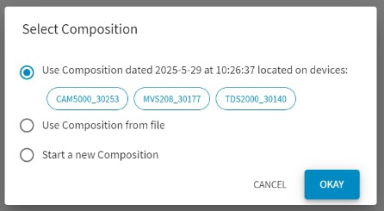
When first launching the Composer there are three options:
- Load an existing Composition from a connected device.
- Load a Composition from a file on the local host.
- Start a new Composition.

New Compositions
Upon selecting “Start a new Composition”, the Composer window will present.

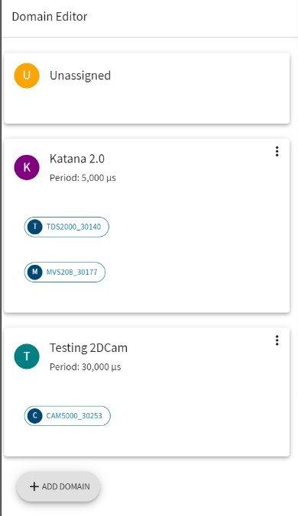

There are a few key elements to notice in this window:
  - The section on the left is titled ‘Domain Editor’.
  - The TDS2000_30020 device is in a card under the ‘Unassigned’ Domain.
  - The ‘Add Domain’ button.
A Domain is a set of devices grouped together that follow the same timing pattern (have the same period). For a device to be configured it must be part of a domain. The next step in creating a Composition is to add a domain. By clicking “Add Domain”, a window will open. Here it is necessary to choose:
  - A unique domain name, which will serve as an identifier.
  - A period/frequency that the domain will follow.
These two fields are the same value represented in different units and only one needs to be set. An example domain with a name of “ComposerDemo”, is shown below. Note that the period has automatically changed to 20,000 µs to reflect the 50 Hz frequency.

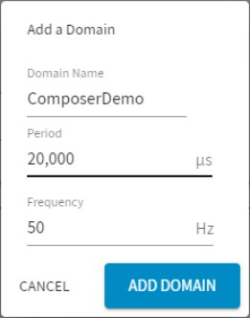

Editing Domain level settings such as name, timing, and removal can be done through the Domain settings menu, accessed through the dotted menu bar.
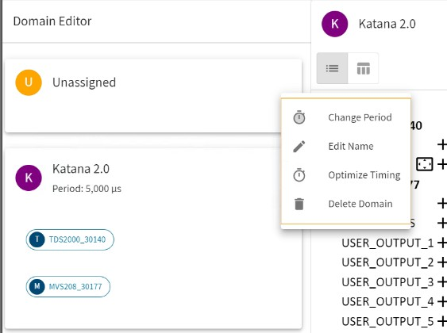
The main Composer window will look like the image below once a domain has been added. It is possible to have more than one domain, but most devices can only be assigned to one domain at a time. A device is added to a domain by dragging and dropping the device card over to the target domain. Then the device will be visible in the Composition Editor on the
right.

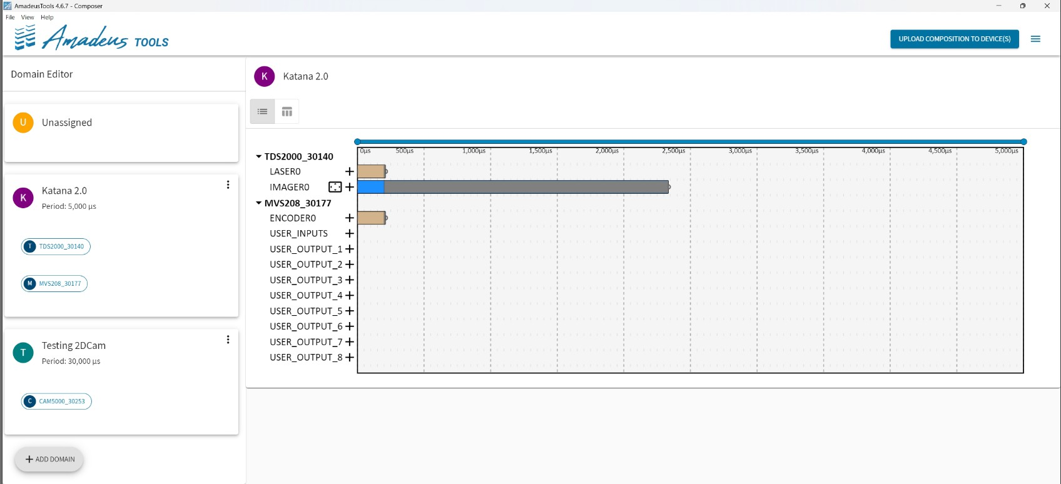

  - Below the device name, the device has reported itself as having both a LASER0 and IMAGER0 module.
  - Beside each Module name is a button to add a new Command for that Module.
  - To the right of this information, there is the main timeline.
  - Along the top is a scale, which starts at 0 µs and runs for 20,000 µs.
Modules are the components within a device that provide a specific functionality that can be controlled by the Composer. For example, with the TDS2000, the laser can be controlled to turn on and off at specific times, and the imager can be controlled to take an image of a specific size at a certain time. Click the plus icon next to the module you’d like to add command to add a new command to the Composition

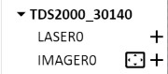

Clicking on a command in the Composition will select it. Once selected, the timing can be edited using the Command Editor Toolbar, or by clicking and dragging the command around the Composition. The command can be deleted by pressing the delete key after it has been selected.
There are certain restrictions in how commands can be timed, dependent on characteristics of the modules. If a command has a period where another command
cannot be issued, this time is displayed as a greyed out area around the command, and the Composer will prevent other commands from being issued in this command.

Changing ROI
The region of interest can be changed by selecting the change region of interest shortcut icon beside the module or by selecting an integration command for the target module and selecting ‘CHANGE ROI’. The selected region of interest will apply to all integration commands for this imager module. The values entered may change after applying them, this is a function of how the imager works and is not avoidable.

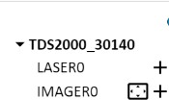
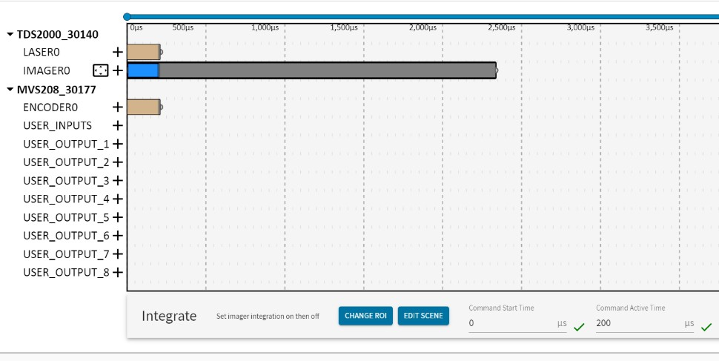

The graphic below will update as you adjust the parameters. If you’d like to reset to the largest ROI, select “Max Extents”.
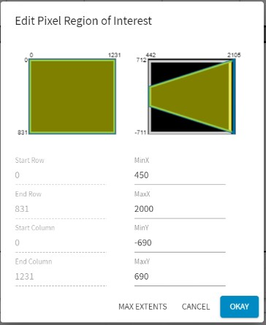
To upload a composition to your devices, click the “Upload Composition to Device(s)”
button at the top of the screen and select the applicable devices. The pop up will tell you when your changes have been successfully uploaded.
